|  |  |
| --- | --- |
| Name: | James Macgillivray |
| Grade: | 9 |
| Subject: | Humanities - Geography |
| Teacher: | SNGT |
| Topic: | Geographies of Interconnections |
| Assessment: | Research Assignment |
| Due date: | Week 9 |

Contents

Introduction 3

The Supply Chain 4

Benefits and Drawbacks of the Production of Tea ….. 4

The effectiveness of Fairtrade on the tea industry in Sri Lanka…… 5

Conclusion 5

Reference List 7

Introduction

**Hypothesis**

The ethicality of the tea industry in developing countries like Sir Lanka is quite low, employing many, low-paid impoverished workers and negatively impacts the environment. Tea is a plant grown in many parts of the world in tropical and humid climates. These locations include southern China, India, Kenya and Sri Lanka (Ronald, 2020). All these tea growing countries grow the plant because they share having access to cheap labour, have acidic soil required by the tea plant, are relatively close to the equator and are at high elevations where tea shrubs thrive (See Figure 1). This report seeks to prove or disprove whether tea harms workers and the environment.

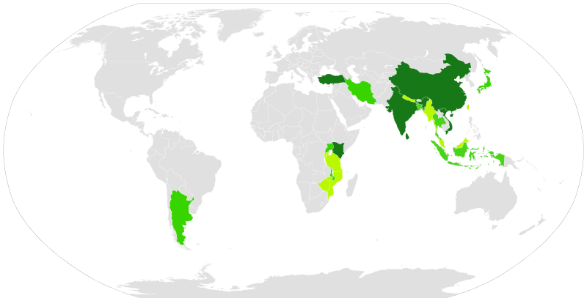

Figure 1: Map of tea-producing countries 2012-2013 (FAOSTAT, 2013)

The Supply Chain

The supply chain of tea from the plant to bags you can buy from the supermarket is quite small with relatively few steps in the production process. The process starts on farms where tea is planted, then handpicked by workers. These farms can be state or privately owned. Mechanical harvesting methods were tried but were not as successful as handpicking as mechanical harvesters cannot decide what leaves are ready to pick and which ones are not (Ronald, 2020). These leaves are then dried, fermented, crushed, heated then cooled by the plantation company ("Orimi”, 2021). This tea is then sent via trains and trucks in very large quantities to brokers who inspect the quality and flavour of the tea (See Figure 2). This broker sells the tea to local consumers, overseas distributors and local traders. The overseas distributors, the main buyers, then blend the tea into whichever flavour they want to sell it in (Jayaratne, 2011). Finally, they bag the tea and ship it to the supermarkets for sale to consumers all around the world.



Figure 2: Map of Tea Growing Districts in Sri Lanka (Jayaratne, 2011)

# Drawbacks of The Production of Tea

The impact of tea production in Sri Lanka has significant social effects on the workers employed by plantation owners. The conditions the employees work in are quite awful with the main concern being the very low wage the workers are paid (Fornell, 2020). One of the jobs created by the tea industry is the tea pluckers, the people who walk around the plantation and pick the leaves which are then turned into tea. These workers are paid in the weight of tea and get deducted pay if they do not pick the required amount. The basic income of these workers is 700 Sri Lankan Rupees per day which converts to roughly five Australian dollars per day (Rajasegar, 2019). In Sri Lanka, poverty among tea plantation workers has been significantly higher than in other sectors (Siegmann, Ananthakrishnan, et al, 2019). This is contrasted to developed countries like Australia who produce a small amount of high-end tea whose workers must be paid a minimum award wage of $20.33 an hour, four times the daily pay in Sri Lanka (Fair Work Ombudsman, 2021). This low wage forces the worker into poverty and eventual malnutrition.

Another negative impact of the Sri Lankan tea industry is the effect it has on the environment. The amount of tea grown takes up a lot of land, about 187,309 hectares which were previously forest and were cleared to be replaced by a more profitable plant in tea ("Tea From Sri Lanka", 2021). This deforestation displaces many animals which rely on the forest to survive. Another environmental issue when farming huge amounts of tea is topsoil erosion from weeding scrapers (Mondal & Mukhopadhyay, 2017). About 30cm of topsoil is eroded every year which is approximately 40 tonnes per hectare per year. This causes a massive loss in fertile soil, sustainable farming land and increased sediment in waterways (Ho, 2021).

# Benefits of Tea Production

Although the production of tea has many drawbacks it has some positives. The tea industry does underpay its workers, but it employs over a million employees and pays those workers much more than other tea producing countries such as Kenya (Fornell, 2020). Another benefit is that tea is cheaper than ever compared to 30 years ago for developed and developing nations due to mass production (Easton, 2014). Tea is an important industry for the Sri Lankan Economy, it is a major export for the country and is a large factor in the country’s GDP of 84 billion ("The World Bank", 2021).

# The effectiveness of Fairtrade on the Tea industry in Sri Lanka

Fairtrade is an organisation designed to make consumers aware of whether the products they are buying are ethically sourced. This involves inspecting the work conditions of the employees and deciding whether they are ethically paid and treated well. Having your company as part of Fairtrade is a good way of attracting more buyers because a conscientious buyer will prefer a product with a Fairtrade sticker.

Fairtrade also works in the Sri Lankan tea industry to certify products. Fairtrade works with estate owners by using money to improve the workers’ pay, worker association (unions), working conditions and general living standards. It is effective at doing this and has a great social impact on the plantations it works with. It achieves this by partnering with mostly small farmers and sends Fairtrade specialists to advise the managers of the estates and to give financial support to help the plantation comply with Fairtrade’s ethical standards (Siegmann, Ananthakrishnan, et al, 2019).

Conclusion

It is clear that the ethical standards of tea plantations in developing countries such as Sri Lanka are low and negatively impacts the environment. This is proven by the mistreatment of workers in a significant number of plantations by paying incredibly low wages, poor working conditions and harsh treatment and various environmental issues caused by the growing and farming of tea.

# Reference List

Easton, M. (2014). *Oxford big ideas geography*. Melbourne: Oxford University Press.

FAOSTAT. (2013). Retrieved 18 August 2021, from http://www.fao.org/faostat/en/#data/QC

Fornell, L. (2020). Sri Lanka's Ceylon tea workers live under a legacy of exploitation. Retrieved 30 August 2021, from https://www.dw.com/en/sri-lanka-tea-workers-and-a-legacy-of-exploitation/a-55006963

Ho, M. (2021). What is Erosion? Effects of Soil Erosion and Land Degradation. Retrieved 22 August 2021, from https://www.worldwildlife.org/threats/soil-erosion-and-degradation

How are tea leaves processed?. (2021). Retrieved 19 August 2021, from http://www.orimi.com/en/potrebitelskaya-entsiklopediya-/chay/chto-delayut-s-chaynym-listochkom/

Jayaratne, P. (2011). Sustainable Supply and Supply Chain Mapping - Sri Lankan Tea Supply Chain Chain. Retrieved 20 August 2021, from https://ro.uow.edu.au/cgi/viewcontent.cgi?article=1037&context=sbshdr

Minimum Wages. (2021). Retrieved 26 August 2021, from https://www.fairwork.gov.au/pay/minimum-wages

Mondal, T., & Mukhopadhyay, M. (2017). Cultivation, Improvement, and Environmental Impacts of Tea. Retrieved 22 August 2021, from https://oxfordre.com/environmentalscience/view/10.1093/acrefore/9780199389414.001.0001/acrefore-9780199389414-e-373

Rajasegar, S. (2019). A Day in Saraswathi’s Life. Retrieved 20 August 2021, from https://groundviews.org/2019/02/06/a-day-in-saraswathis-life-video/

Ronald, H. (2020). *Tea production*. Encyclopedia Britannica. Retrieved 18 August 2021, from https://www.britannica.com/plant/tea-plant.

Siegmann, K., Ananthakrishnan, S., & Fernando, K. (2019). Fairtrade certified tea in the hired labour sector in India and Sri Lanka: Impact study and baseline data collection. Retrieved 22 August 2021, from https://files.fairtrade.net/publications/Fairtrade-study-tea-hired-labour-in-India-and-Sri-Lanka.pdf

Tea From Sri Lanka. (2021). Retrieved 30 August 2021, from https://www.srilankabusiness.com/pdf/tea-ebrochures-1.pdf

World Development Indicators | DataBank. (2021). Retrieved 31 August 2021, from https://databank.worldbank.org/reports.aspx?source=2&series=NY.GDP.MKTP.CD&country=WLD